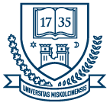 | UNIVERSITY OF MISKOLC  FACULTY OF HEALTH SCIENCES  Faculty Scientific Student Council | 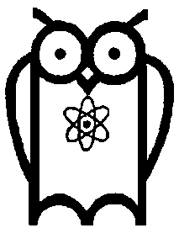

CALL FOR CONFERENCE PARTICIPATION

SCIENTIFIC STUDENTS’ CONFERENCE

Date of the conference: November 27, 2025
Place of the conference: Faculty of Health Sciences, University of Miskolc, Hungary
Registration deadline: October 20, 2025 (Form is attached)
Format of the conference:
- For Hungarian participants: on-site attendance
- For international participants: hybrid format (on-site and online participation possible)
Eligibility: Students enrolled in a higher education institution in the academic year 2025/2026 are eligible to apply.
Conference languages: Hungarian and English
Participation fee: Participation is free of charge

Presentation details:
- Each presentation is 10 minutes long, followed by a 5-minute discussion.
- A maximum of two students may be indicated as authors of the presentation.
- The topic of the presentation must be related to health in some way.
- Presentation must be accompanied by projector slides.

Abstracts:
An abstract booklet will be compiled from the presentations delivered at the conference. Abstracts submitted in Hungarian will be published in Hungarian, and those submitted in English will be published in English.
Abstracts must be sent to the e-mail address provided below no later than November 17, 2025, in the language of the presentation. Please do not change the format of the abstract template and do not exceed one page.
After confirming your participation, we will assist you in completing the central registration process.
We warmly welcome all participants to our conference!

Andrea Lukács, PhD, habil,  Associate Professor  President of the Faculty Scientific Student Council  andrea.lukacs@uni-miskolc.hu | Barbara Guzi  Senior Lecturer  Secretary of the Faculty Scientific Student Council  barbara.guzi@uni-miskolc.hu

